Spring Horse Care Tips: How Safe is Your Horse's Water?
Drs. Foster & Smith Educational Staff
 | 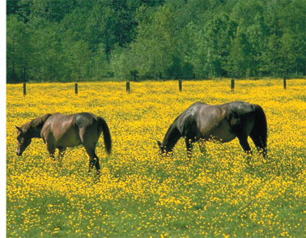
Would you drink your horse's water? Is it crystal clear and tasty? Or is it filled with algae, debris, and insects?
Too often, horses are expected to drink foul, smelly water laden with litter. But fresh, clean water is essential to your horse's health. Thankfully, there are simple ways to help keep drinking water in the stall, barn, and pasture clean, debris- and toxin-free, and delicious.
your horse's water needs
Horses, like humans and other animals, need water above all else to survive. Generally, a horse at rest should drink at least one gallon of water per day for every 100 pounds of body weight. But every horse is different. For instance, an active 1,200-pound draft horse may need more than 12 gallons of daily drinking water. Similarly, a 700-pound Criollo on lush, green pasture may need slightly less than 7 gallons of water per day. Regardless, there are several factors that can alter your horse's water needs, including:
 | Activity Level |  | Air Temperature |  | Diet and Forages
 | Humidity Level |  | Overall Health |  | Pregnancy or Nursing
 | Shows and Competitions |  | Training Schedule |  | Travel and Trail Rides
the benefits of water
Your horse's health is tied to the water she drinks. Water is the basis for life. It is necessary for proper function of every cell and organ in the body. In fact, serious medical conditions can result when horses do not consume adequate amounts of water every day of the year. Drinking water helps prevent dry hay from becoming impacted, which could cause colic. Water consumption also helps eliminate the excess nitrogen consumed when horses eat large quantities of high-protein alfalfa hay. Water consumption also helps prevent dehydration.
a simple test for dehydration
Perform this simple test to check if your horse is dehydrated:
Gently pinch your horse's neck skin into a tent
Release the skin you have gathered
The skin should snap back immediately
If the skin doesn't snap back, your horse is dehydrated

Dehydration prevention is especially important during the warmer weather of spring and summer. Serious cases of dehydration have killed horses in as few as two days. The signs of dehydration include an unjustifiable loss of body weight, fever, increased breathing rates, lethargy, a lack of appetite, dry mucous membranes, sunken eyes, and a decreased ability to perform.
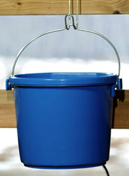
simple ways to provide cleaner, fresher water
There are a variety of ways to offer water to your horse. Water buckets, water troughs, automatic waterers, and more help ensure a supply of water is always available to your horse. However, keeping your horse's drinking water clean and fresh is often a much more difficult task. The following tips will help ensure your horse's water is always as clean as possible:
use hanging buckets - hang a suitable water bucket in your horse's stall. By lifting the bucket off of the stall floor you help prevent waste, bedding, food, and other debris from falling into the water. A hanging bucket also helps prevent your horse from knocking the bucket over and spilling her water.
clean waterers often - remove leaves, hay, insects, and other debris daily. Then refill your horse's bucket with fresh, clean water. Depending on how clean the water stays, occasionally scrub the bucket with a bristle brush and vinegar. Rinse well. Clean stock tanks with a simple, drop-in cleaner. If insect contamination is a problem consider perimeter sprays and traps to help control them. In water troughs, consider an insect control additive, such as the Mosquito Torpedo, and clean with a scraper.

monitor contaminants - check contaminant levels in any drinking water source. Many local municipalities and Environmental Protection Agency offices test water samples. It is especially important to test your water after floods, heavy storms, and after any damage to wells or plumbing systems is incurred.
move manure piles - relocate manure piles away from water sources. Generally, keep manure piles at least 500 to 1,000 feet away from any pond, stream, well head, or other water source. Fecal-borne bacteria, such as Salmonella, sicken many horses every year.
limit chemical use - follow use instructions for pesticides, herbicides, and fertilizers. Each is designed for use at a certain formula or ratio. Increasing this ratio will not kill more insects or weeds or make your grass any greener. Instead, excess chemicals will leach into your ground water and, eventually, end up in your home's drinking water.
fence off natural water sources - fences help prevent your horse from drinking from natural water sources in your pasture. The blue-green algae that blooms in many ponds, lakes, and streams is toxic to horses in large quantities. Wildlife waste can also contaminate water sources. Fertilizers, herbicides, and pesticides may also pool in unkempt water sources. If a pond must be used for a water source, use an aeration system to circulate the water and test it frequently.

